**Group name: database group**

**Phase 1 _** **Group Formation and Conceptual Data Model**

**Group’s Members Info:**

|  |  |
| --- | --- |
| **Student Name** | **Id** |
| **Layan alsudais** | **443010718** |
| **Alanoud alsaleem** | **442021963** |
| **Reema alaboudi** | **443013841** |

**Group Leader: Reema alaboudi**

**Data Modeling Tool:** <https://www.lucidchart.com/pages/>

**Assumptions**

* EducationalBackground: Weak entity tied to User, storing details of each user's education.
* Quiz: Part of a Module, tracked by deadline and max marks.
* StudyGroup: Groups formed by users, containing multiple posts.
* ConversationThread: Discussion threads related to courses.
* QuizAttempt: Records user attempts for quizzes

|  |  |  |
| --- | --- | --- |
| Entity | Attribute | Desc |
| User | UserID (Primary Key)  Password  EmailAddress  ProfilePicture | Stores registered user information |
| Course | CourseID (Primary Key)  Description  TopicsCovered  InstructorID (Foreign Key)  StartDate  EndDate | Represents courses information |
| Module | ModuleID (Primary Key)  Module name | Components of courses |
| Lecture | LectureID (Primary Key)  VideoContent  TextSummary  Duration | Part of a module, includes video and text content |
| Assignment | AssignmentID (Primary Key)  ModuleID (Foreign Key)  SubmissionDeadline  MaxMarks | Module assignments |
| Quiz | QuizID (Primary Key)  ModuleID (Foreign Key)  SubmissionDeadline  MaxMarks | Module quizzes |
| Submission | SubmissionID (Primary Key)  UserID (Foreign Key)  AssignmentID (Foreign Key)  Timestamp | Tracks assignment submissions |
| QuizAttempt | QuizAttemptID (Primary Key)  UserID (Foreign Key)  QuizID (Foreign Key)  Score | Records quiz attempts |
| StudyGroup | GroupID (Primary Key)  DiscussionForum (Relationship with Post entity) | User-formed study groups |
| Post | PostID (Primary Key)  GroupID (Foreign Key)  UserID (Foreign Key)  Timestamp | PostID (Primary Key)  GroupID (Foreign Key)  UserID (Foreign Key)  Timestamp |
| Instructor | InstructorID (Primary Key)  Biography | Instructor profiles |
| Announcement | AnnouncementID (Primary Key)  CourseID (Foreign Key)  Timestamp | Course-related announcements by instructors |
| Feedback | FeedbackID (Primary Key)  UserID (Foreign Key)  CourseID (Foreign Key)  Ratings  TextComments | User feedback on courses/instructors |
| Certificate | CertificateID (Primary Key)  UserID (Foreign Key)  CourseID (Foreign Key)  DateOfIssuance | Certificates for completed courses |
| Message | MessageID (Primary Key)  SenderID (Foreign Key)  ReceiverID (Foreign Key)  Timestamp  ThreadID (Foreign Key) | User messages in conversation threads |
| ConversationThread | ThreadID (Primary Key)  CourseID (Foreign Key, nullable for general queries) | Threads for course-related discussions |
| EducationalBackground | UserID (Foreign Key, part of the primary key)  Degree  Institution  GraduationYear | Weak entity linked to User, stores educational history |

**Description: ER Data Model component:**

User --(1-to-M)-- EducationalBackground

User --(M-to-M through Enrollment)-- Course

Course --(1-to-M)-- Module

Module --(1-to-M)-- Lecture

Module --(1-to-M)-- Assignment

Module --(1-to-M)-- Quiz

Assignment --(M-to-1)-- Submission

Quiz --(M-to-1)-- QuizAttempt

User --(M-to-M through StudyGroupMembership)-- StudyGroup

StudyGroup --(1-to-M)-- Post

User --(1-to-M)-- Post

Instructor --(1-to-M)-- Course

Instructor --(1-to-M)-- Announcement

Course --(1-to-M)-- Feedback

Course --(1-to-M)-- Certificate

Course --(1-to-M)-- ConversationThread

ConversationThread --(1-to-M)-- Message

User --(1-to-M as SenderID and ReceiverID)-- Message

**Conceptual Data Model**

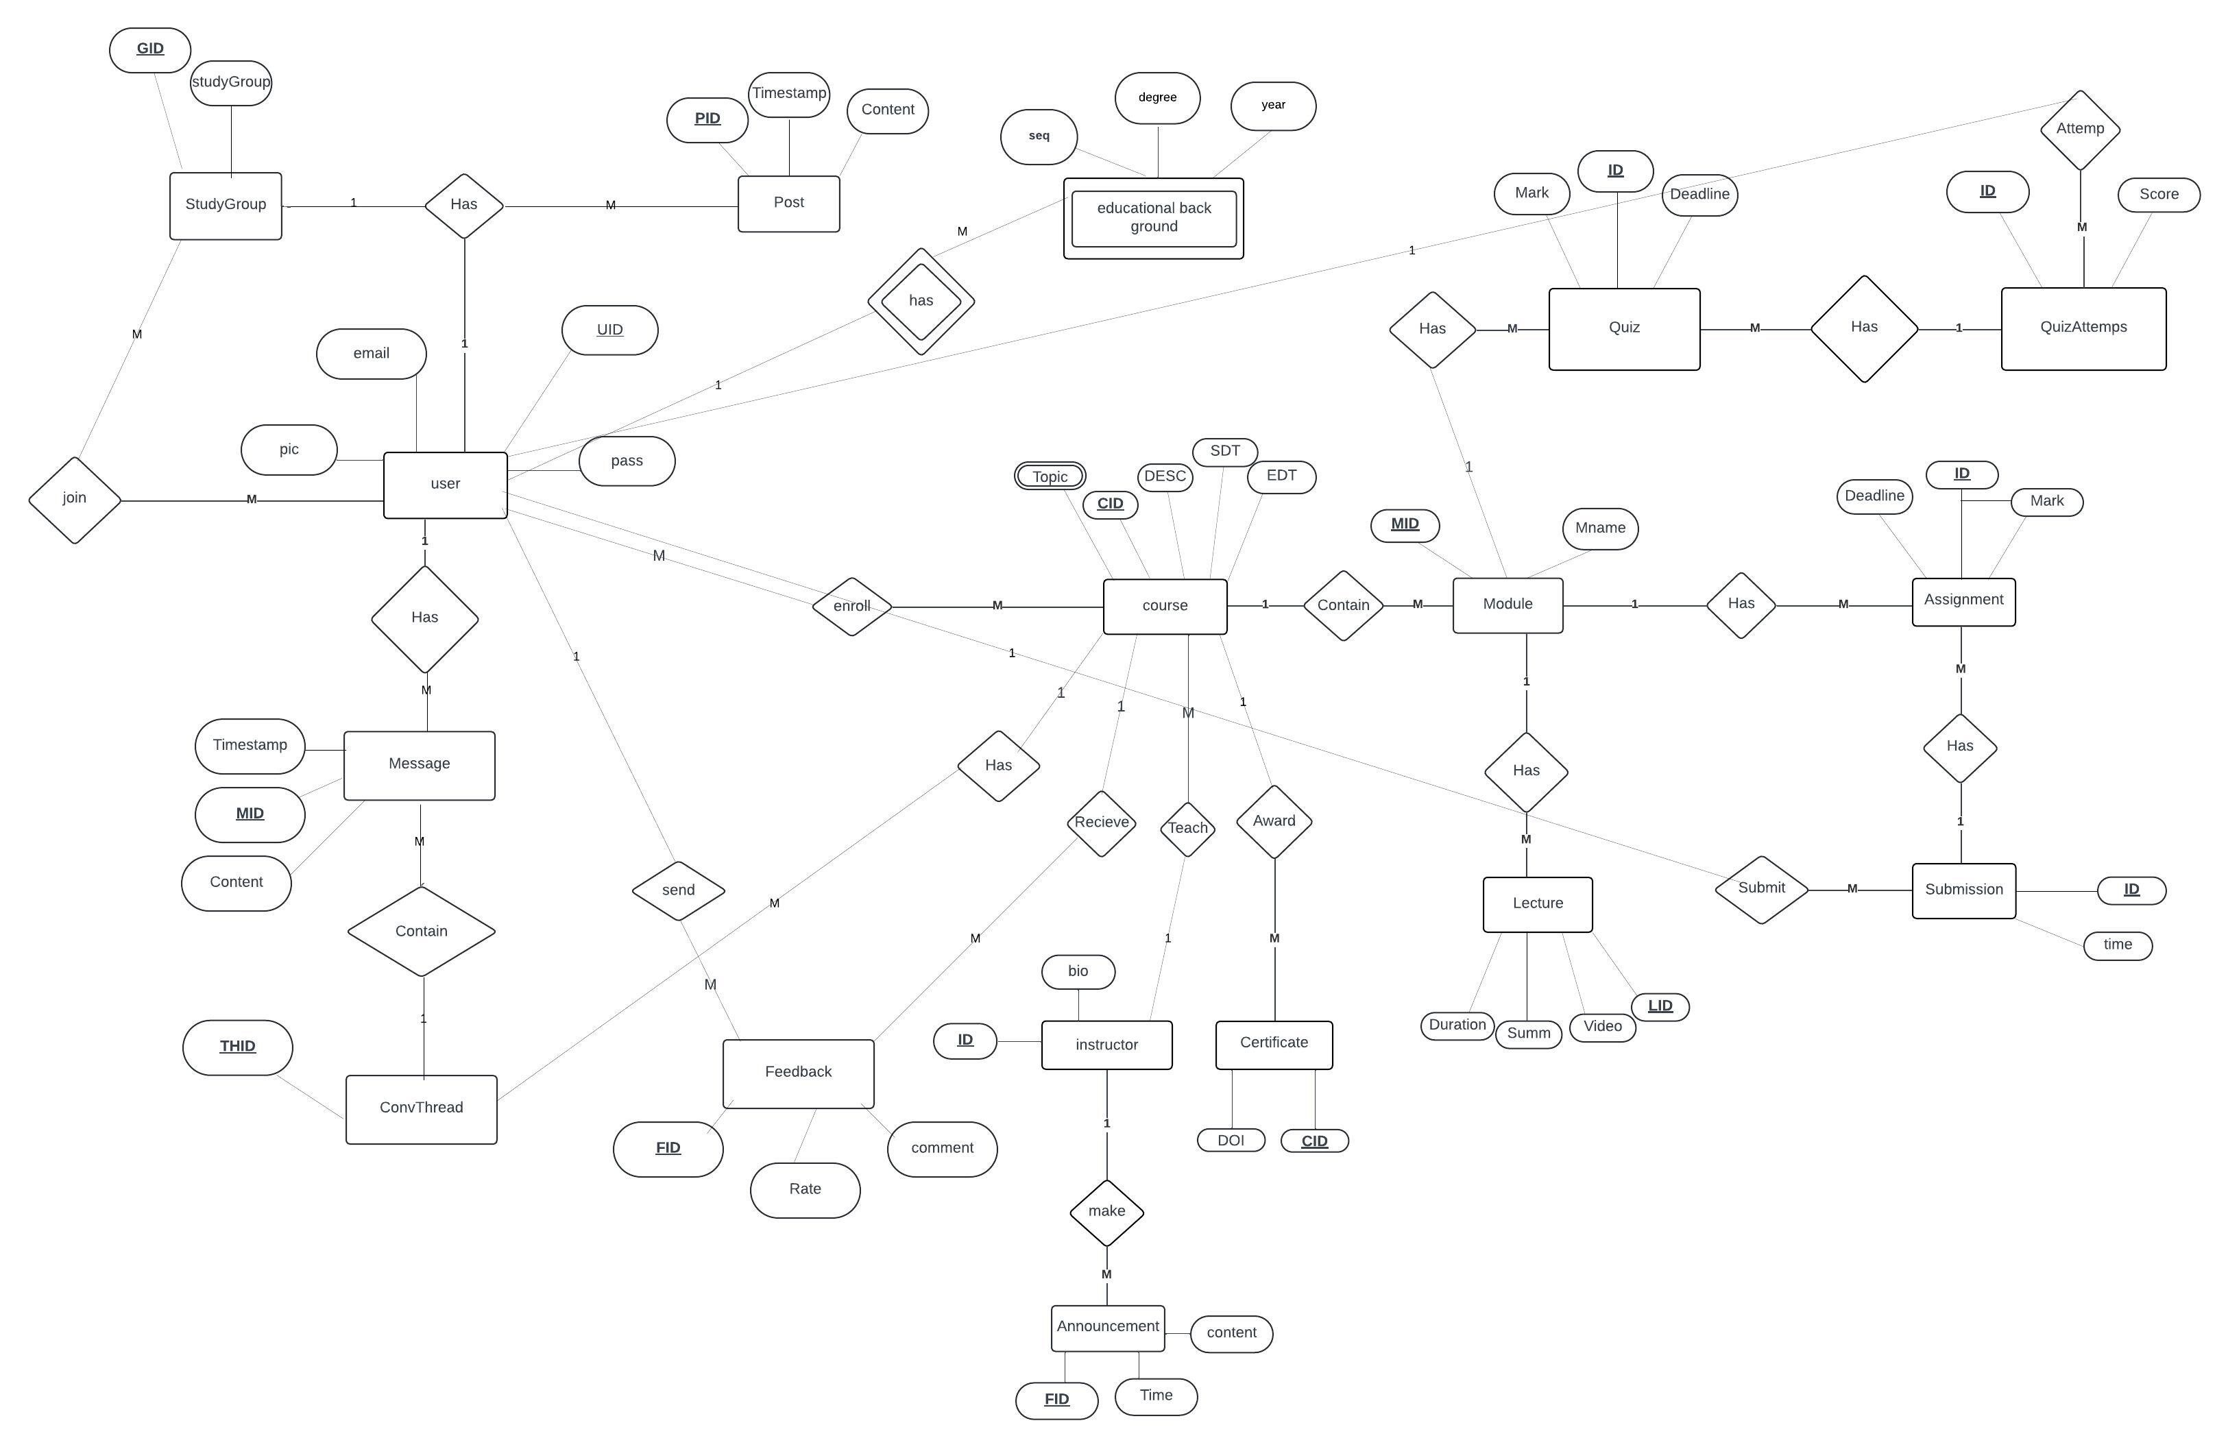

**Phase 2**

**Relational Database Schema**

